Microsoft Intune macOS Applications
Zero-to-Advanced Master SOP with Google Chrome PKG Example
Plan | Select App Type | Validate Package | Configure | Detect | Assign | Monitor | Troubleshoot | Update
Purpose
A complete operational and learning guide for creating, deploying, monitoring, updating, and troubleshooting macOS applications in Microsoft Intune. The worked example follows the attached Google Chrome PKG screenshots and also explains DMG, managed LOB PKG, built-in Microsoft apps, scripts, lifecycle, and interview concepts.

Document field | Value
Owner | Endpoint Management / IT Operations
Platform | Microsoft Intune and Apple macOS
Worked example | Google Chrome PKG
Source screenshots | Attached macos Apps.docx
Version | 1.0
Prepared date | 23 September 2026
Classification | Internal use

1. macOS App Management Fundamentals

1.1 End-to-end flow
- Prepare Intune and Apple prerequisites.
- Enroll and validate a test Mac.
- Choose the correct macOS app type.
- Download the official enterprise installer.
- Validate signature, architecture, installation, bundle ID, and version.
- Create the app in Intune and upload PKG or DMG.
- Configure metadata, scripts, minimum OS, and detection.
- Assign to a pilot group.
- Sync, install, verify, monitor, and troubleshoot.
- Update, replace, uninstall, and document the lifecycle.

1.2 macOS app type decision guide
App type | Use when | Key point
Microsoft 365 Apps for macOS | Deploy Office suite | Built-in wizard; Microsoft AutoUpdate manages updates
Microsoft Edge for macOS | Deploy Edge | Built-in app type
Microsoft Defender for Endpoint | Deploy security client | Requires onboarding/configuration policies too
macOS app (PKG) | Unmanaged or complex PKG, scripts, nonstandard paths | Supports broad PKG structures and pre/post scripts
Line-of-business app | Signed managed PKG meeting Apple/Intune requirements | Managed deployment; stricter package requirements
macOS app (DMG) | DMG contains one or dependent .app bundles | Agent copies app bundle and uses bundle detection
Web app / Web link | Publish a URL | No native binary installation
Apple volume-purchased app | Mac App Store app synced from Apple Business Manager | License and token based
Most important decision
Do not select an app type only because the file ends in .pkg. Inspect the package structure, signing, payload, install location, scripts, and manageability first.

2. Prerequisites and Packaging Workstation

2.1 Tenant and device prerequisites
- Microsoft Intune tenant with appropriate licenses and RBAC.
- Apple MDM push certificate configured and valid.
- macOS device enrolled and visible in Intune.
- Required user/device groups created.
- Microsoft Intune management agent installed for PKG/DMG agent-based deployment.
- Test Mac representing Intel and/or Apple silicon architectures used in production.
- A change record, vendor source, support owner, and rollback plan.

2.2 Recommended folder structure
~/IntuneApps/
Sources/
GoogleChrome/
154.0.x/
GoogleChrome.pkg
Scripts/
Chrome/
preinstall.sh
postinstall.sh
Evidence/
signatures/
test-logs/
Documentation/

2.3 Local package validation on a Mac
# File and signature
file GoogleChrome.pkg
pkgutil --check-signature GoogleChrome.pkg

# Package metadata and contents
pkgutil --pkg-info-plist GoogleChrome.pkg
pkgutil --expand-full GoogleChrome.pkg ./ChromeExpanded

# Test installation
sudo installer -pkg GoogleChrome.pkg -target / -verboseR

# App identity and version
defaults read "/Applications/Google Chrome.app/Contents/Info.plist" CFBundleIdentifier
defaults read "/Applications/Google Chrome.app/Contents/Info.plist" CFBundleShortVersionString

# Installed package receipts
pkgutil --pkgs | grep -i chrome

Architecture check
On Apple silicon, verify whether the app is Universal, arm64 native, or Intel-only. Intel-only software can require Rosetta 2. Test the exact production scenario.

3. Open macOS Apps and Select the Correct Type
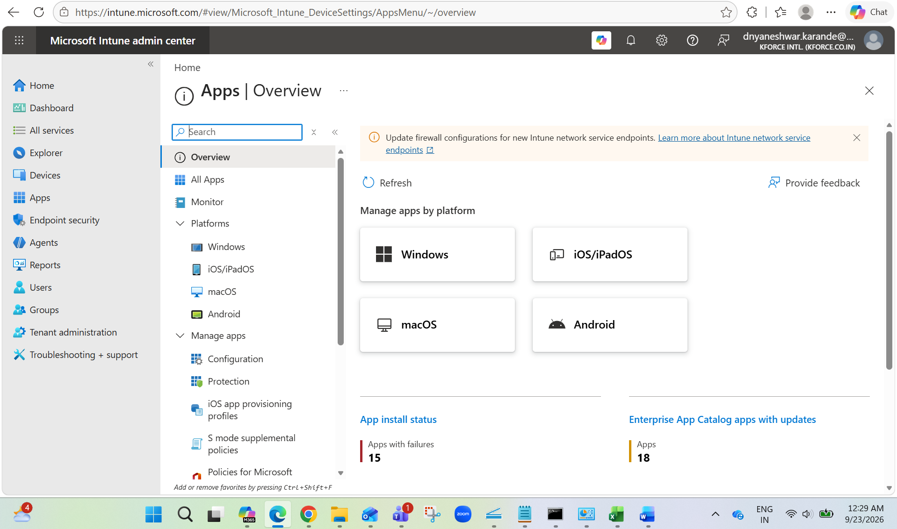
Step 1. From Apps overview, select macOS.
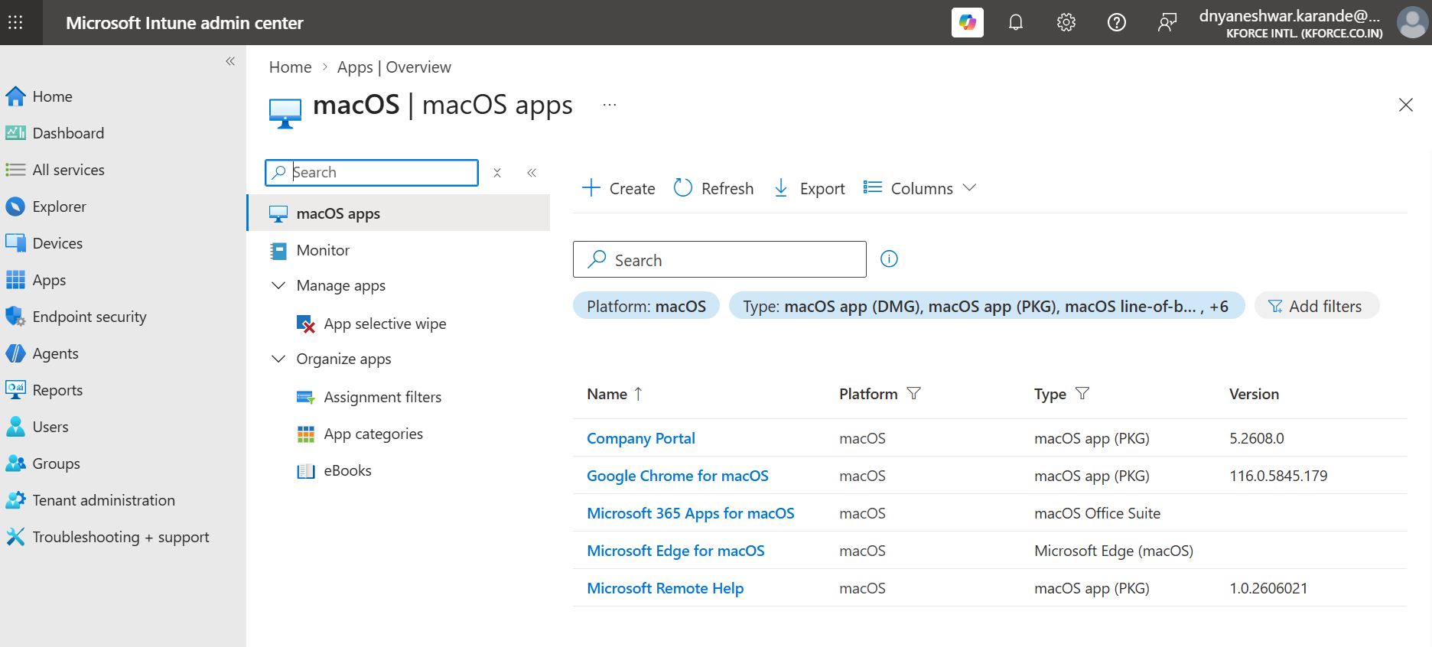
Step 2. The macOS apps list shows existing apps, types, and versions. Select Create.

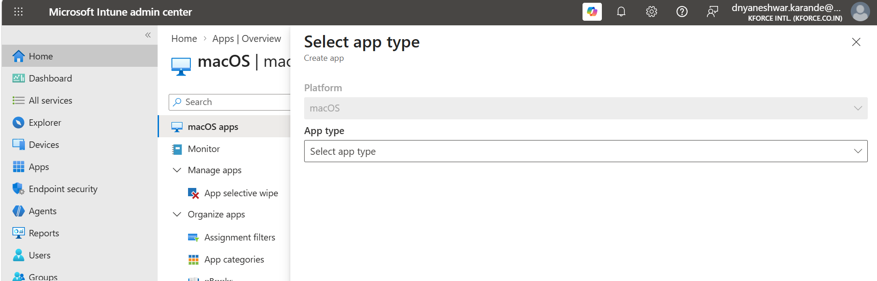
Step 3. The Select app type pane opens with Platform set to macOS.
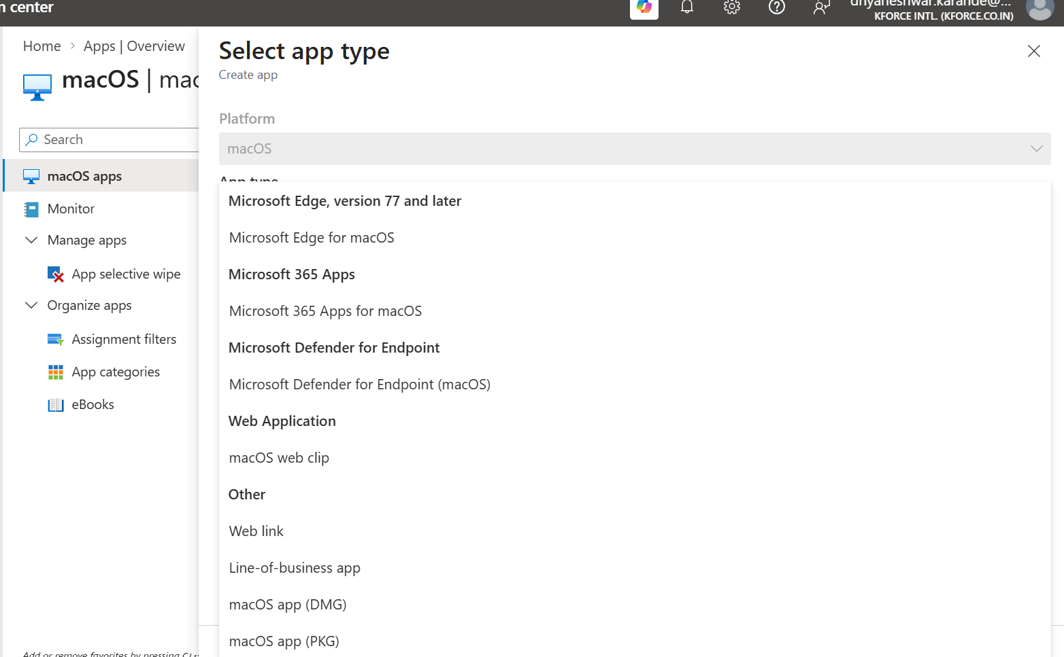
Step 4. Review the available macOS app types before selecting one.
Worked example
The attached workflow uses macOS app (PKG) and GoogleChrome.pkg. This app type is suitable for an unmanaged PKG and provides Program, Requirements, Detection rules, and Assignments pages.

4. Download and Validate Google Chrome PKG
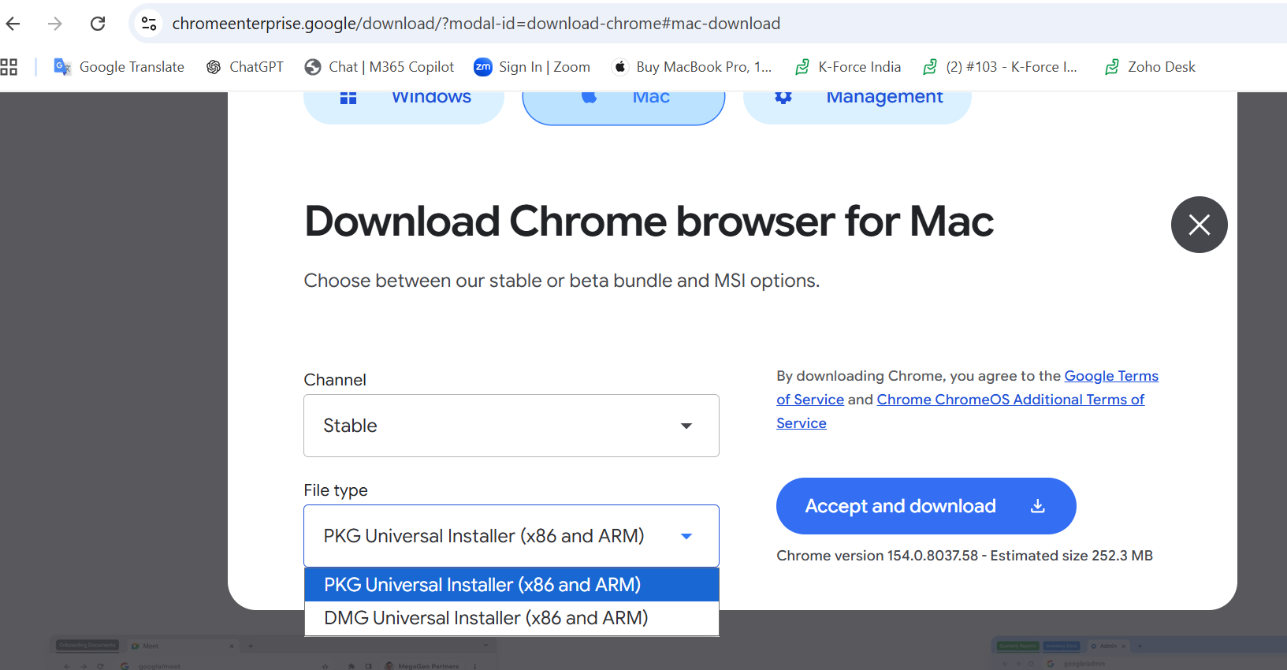
Step 5. From the official Chrome Enterprise download page, select Stable and PKG Universal Installer for x86 and ARM.
- Prefer the Universal enterprise PKG when the estate contains Intel and Apple silicon Macs.
- Avoid consumer DMG or online bootstrap installers when an enterprise PKG is available.
- Record the vendor URL, download date, version, size, architecture, and signature result.
- Test installation and application launch on a clean pilot Mac.

4.1 Decide PKG versus DMG
Condition | Choose PKG | Choose DMG
Vendor provides enterprise installer | Preferred | Only if PKG is unavailable
Package runs scripts or installs helpers | Yes | Usually no
DMG contains a clean .app bundle | Not required | Yes
Nonstandard install locations | macOS app (PKG) | Not recommended
Managed signed component package | LOB app may be suitable | No

5. Create macOS App (PKG) and Upload Package
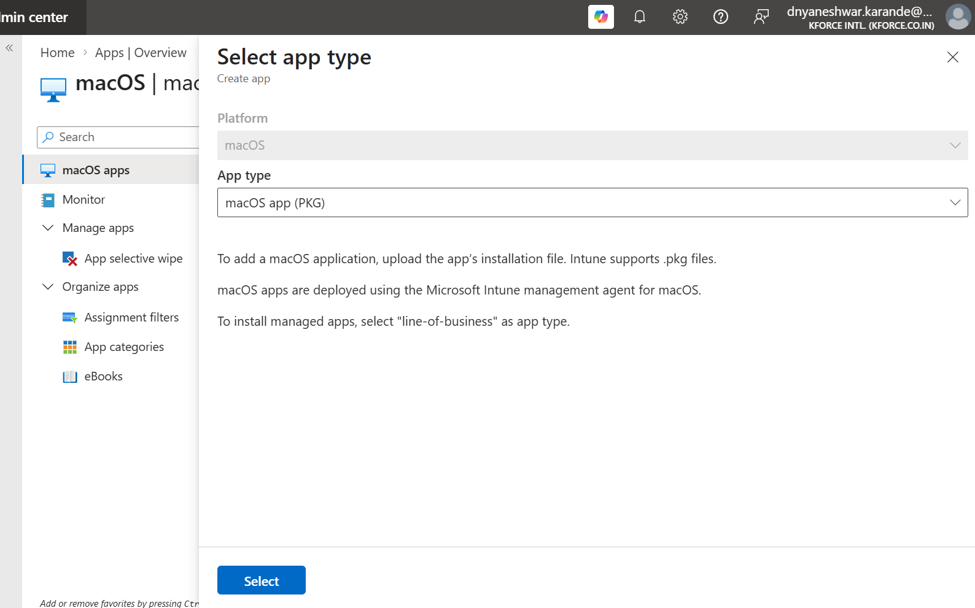
Step 6. Select macOS app (PKG), then select Select.
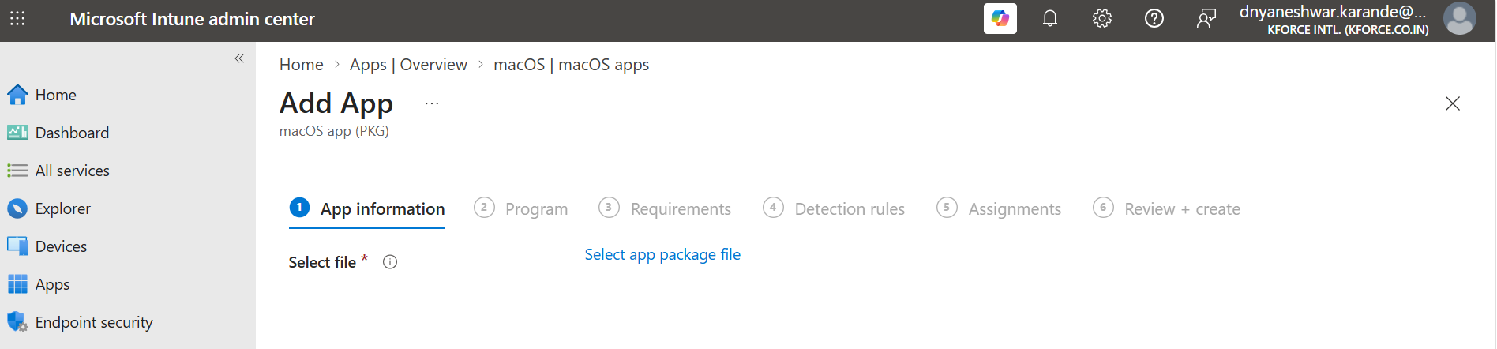
Step 7. The Add App wizard starts at App information. Select the app package file.
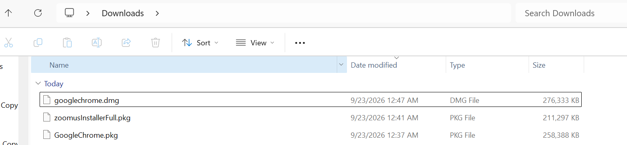
Step 8. Confirm downloaded installer files in the working folder.
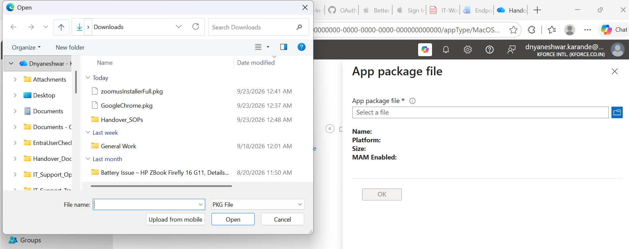
Step 9. Browse to the PKG package. Select GoogleChrome.pkg and choose Open.

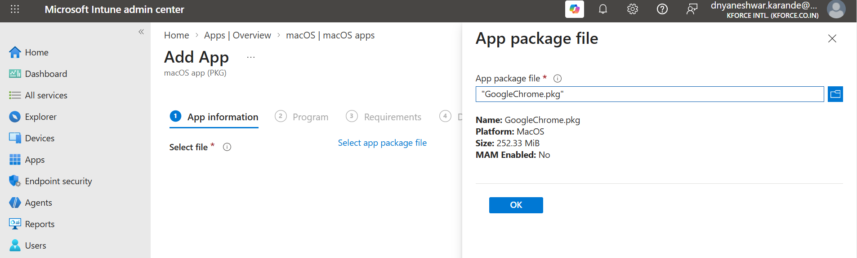
Step 10. Intune reads GoogleChrome.pkg metadata. Confirm the selected package and choose OK.
PKG prerequisites
For macOS app (PKG), the device must be Intune-managed, the package must meet the current size limit, the macOS Intune agent must be installed, and the package must successfully run with the macOS installer command.

6. App Information
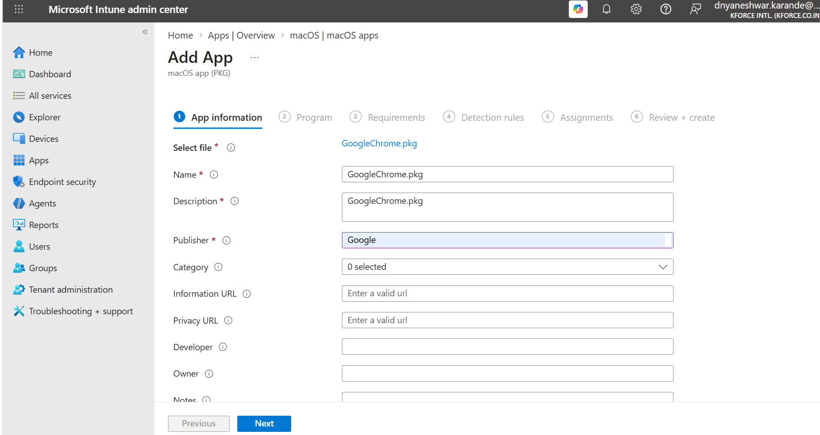
Step 11. Complete Name, Description, Publisher, Category, URLs, Developer, Owner, Notes, and Logo.
Field | Google Chrome example | Guidance
Name | Google Chrome for macOS | Keep the name unique and user-friendly
Description | Managed enterprise browser for macOS | State purpose and support ownership
Publisher | Google LLC | Use vendor identity
App version | Actual package version | Record for lifecycle control
Category | Productivity | Improves Company Portal discovery
Information URL | Official Chrome Enterprise page | Optional
Privacy URL | Official vendor privacy page | Optional
Developer / Owner | Google / Endpoint Management | Supports handover
Notes | Ticket, source, signature, test date | Operational evidence
Logo | Approved Chrome icon | Improves Company Portal
Versioning
Do not use the package filename as the only version record. Capture CFBundleShortVersionString, package receipt/version, source date, and change ticket.

7. Program and Optional Scripts
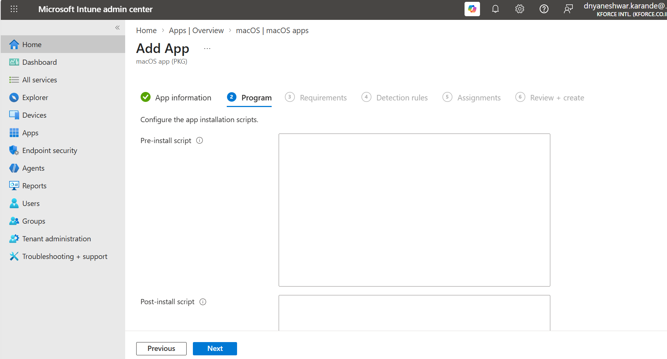
Step 12. Program page allows pre-install and post-install scripts for PKG deployment.

7.1 When to use scripts
- Pre-install: close processes, remove conflicting editions, validate prerequisites, or prepare directories.
- Post-install: write managed configuration, repair permissions, install helper configuration, or validate state.
- Do not embed passwords, tokens, private keys, or secrets.
- Scripts must be noninteractive, idempotent, root-safe, and return meaningful exit codes.
- Use Unix LF line endings and a valid shell interpreter line.
#!/bin/zsh
# Example pre-install skeleton
set -euo pipefail
LOG="/Library/Logs/Company/GoogleChrome-preinstall.log"
mkdir -p "$(dirname "$LOG")"
exec >> "$LOG" 2>&1
echo "Starting pre-install $(date)"
pkill -x "Google Chrome" || true
exit 0

Chrome configuration
Browser settings should normally be managed by Intune configuration profiles or preference policies, not hard-coded into an installation script.

8. Requirements
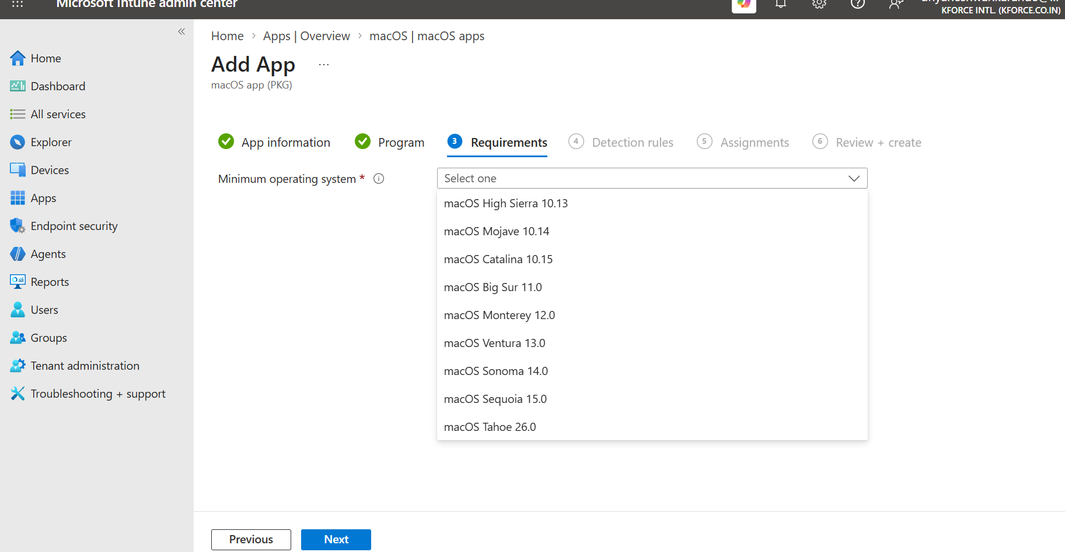
Step 13. Select the minimum operating system supported by the package and organization.
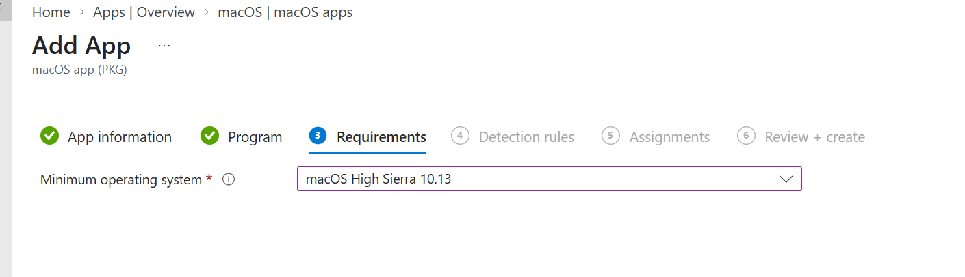
Step 14. Example selection shown: macOS High Sierra 10.13. Use the current approved baseline instead of copying an old value.
Decision | Guidance
Minimum macOS | Use the higher of vendor minimum and organizational support baseline
Architecture | Validate Universal, arm64, or x86_64 locally
Rosetta | Deploy only when Intel-only software requires it on Apple silicon
Disk space | Confirm adequate free space for package and temporary extraction
Security controls | Prepare PPPC, system extension, network filter, login item, or notification profiles where required
Do not blindly copy screenshots
The screenshot value is historical test data. A production package created on 23 September 2026 must use the current vendor-supported macOS baseline and organizational standard.

9. Detection Rules
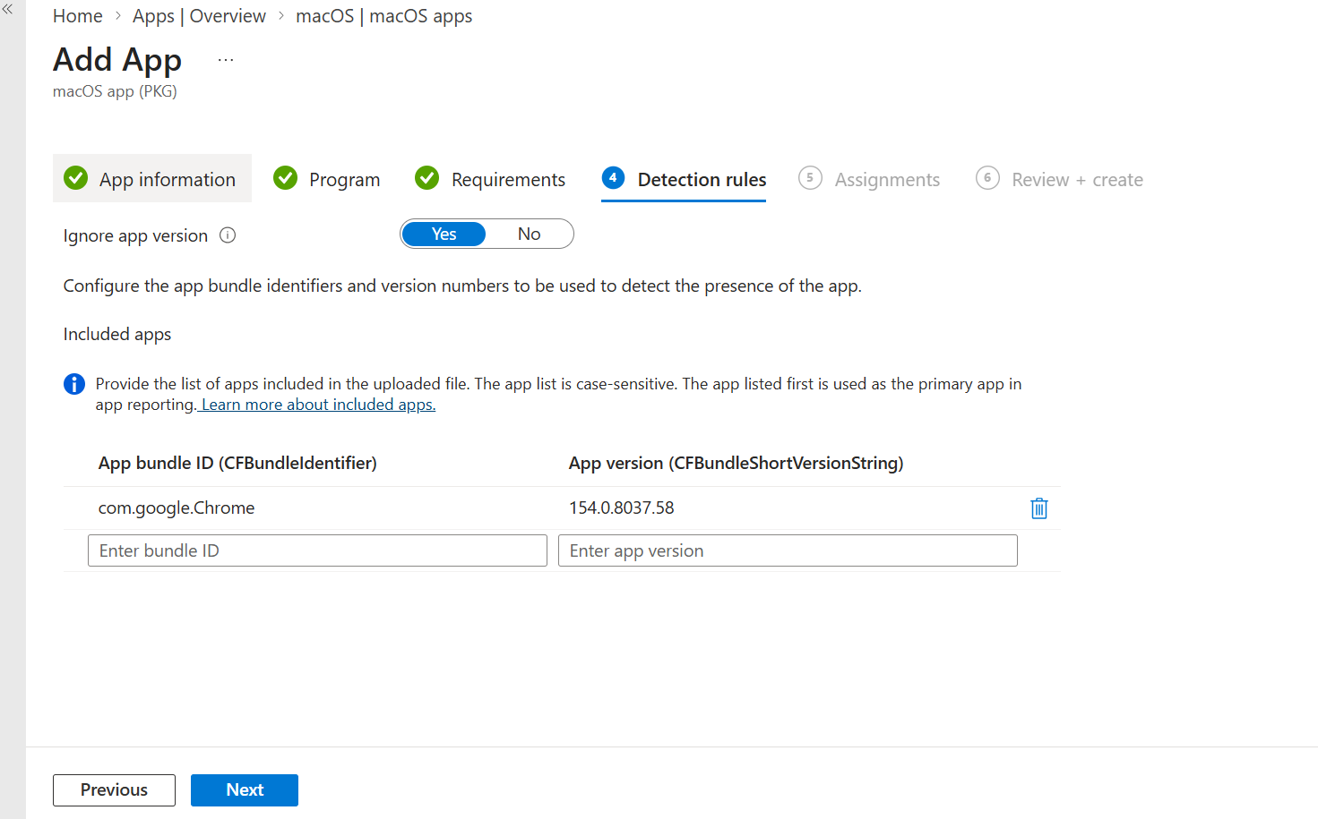
Step 15. Detection rules show Ignore app version and Included apps.

9.1 Chrome identity
Bundle ID: com.google.Chrome
App path: /Applications/Google Chrome.app
Version source: CFBundleShortVersionString

Setting | Recommended decision | Effect
Included apps | Place Google Chrome as the primary app | Used for detection and reporting
Bundle ID | com.google.Chrome | Case-sensitive application identity
App version | Use package/app version | Supports version-aware detection
Ignore app version = No | Use when Intune must enforce a particular or newer package state | Version participates in detection
Ignore app version = Yes | Use when vendor self-update is authoritative | Presence is detected without exact version enforcement
Version strategy
Chrome commonly self-updates. Decide whether Google Update or Intune controls version. If Ignore app version is Yes, Intune primarily detects presence. If No, package updates and detection must be maintained carefully.

10. Assignments and Deployment Rings
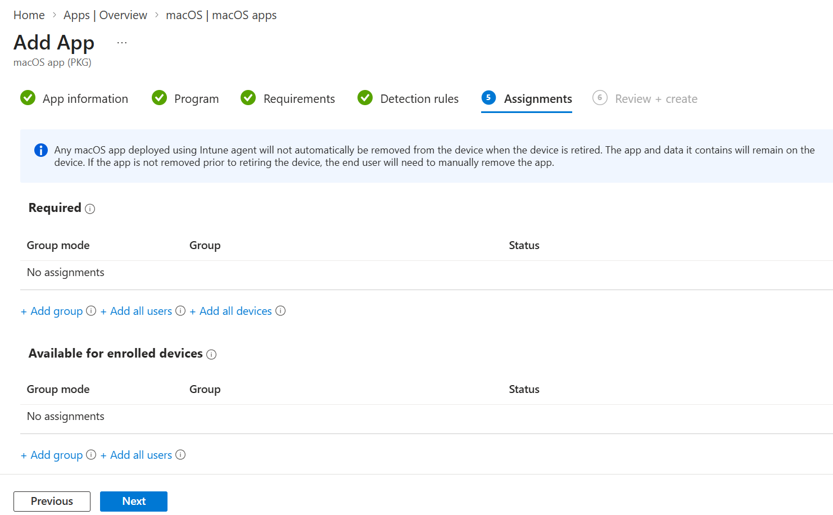
Step 16. Assign the app as Required or Available for enrolled devices.
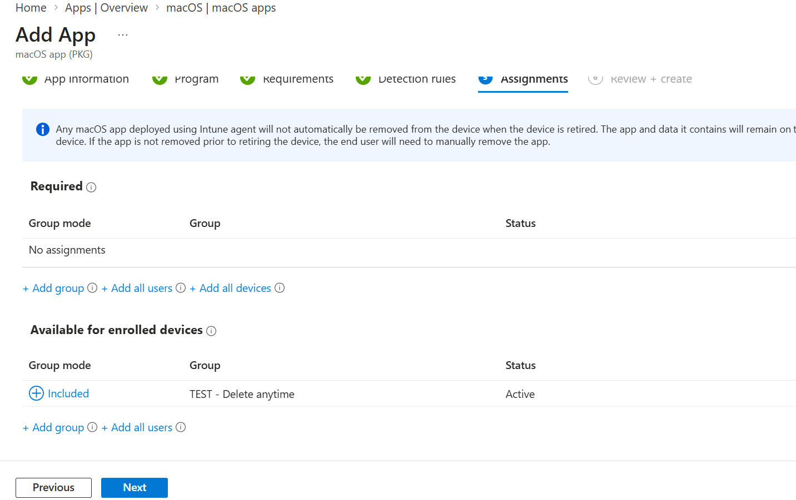
Step 17. Example Available assignment to a test group.
Assignment | Behavior | Use
Required | Intune installs automatically | Mandatory corporate software
Available for enrolled devices | User installs from Company Portal | Optional software
Uninstall / removal behavior | Depends on app type and platform behavior | Validate before relying on retirement
- Ring 0: packaging Mac.
- Ring 1: Endpoint Management pilot.
- Ring 2: mixed Intel and Apple silicon business pilot.
- Ring 3: phased production.
- Ring 4: broad deployment after success criteria.
Screenshot warning
The portal states that some macOS apps deployed using the Intune agent are not automatically removed when a device is retired. Test removal and document manual cleanup when required.

11. Review, Create, and Handle Errors
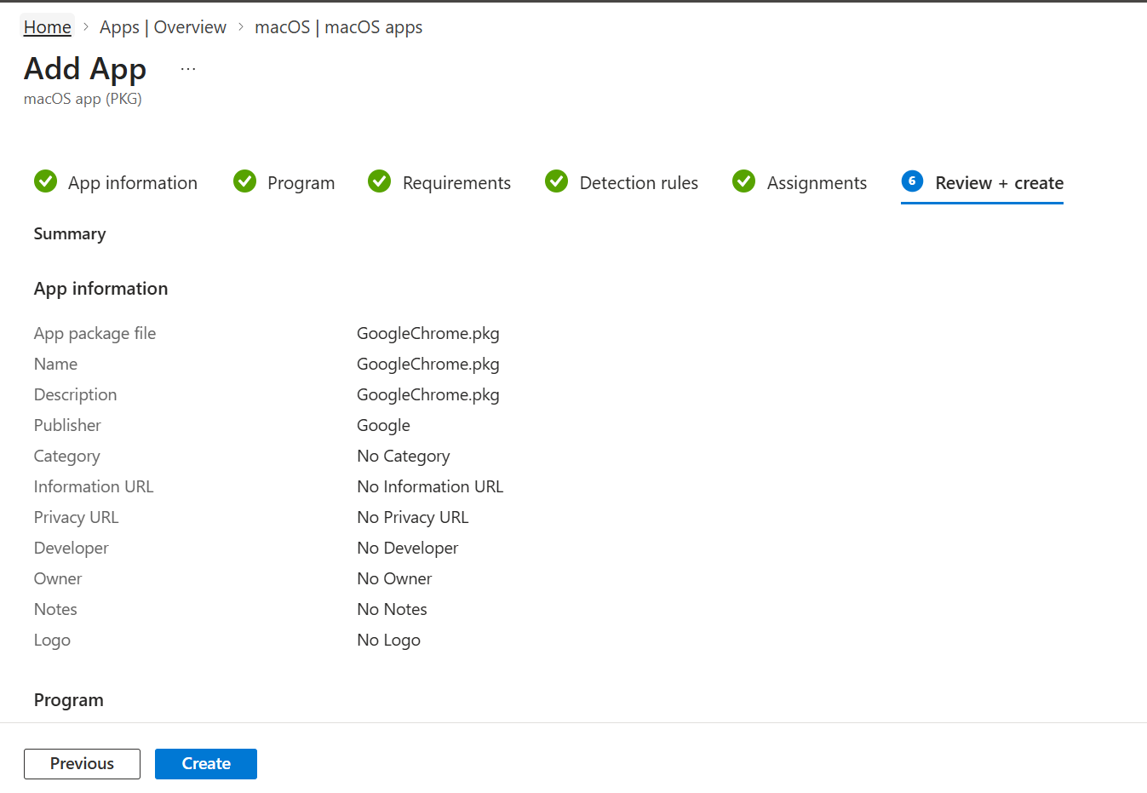
Step 18. Review app information before selecting Create.
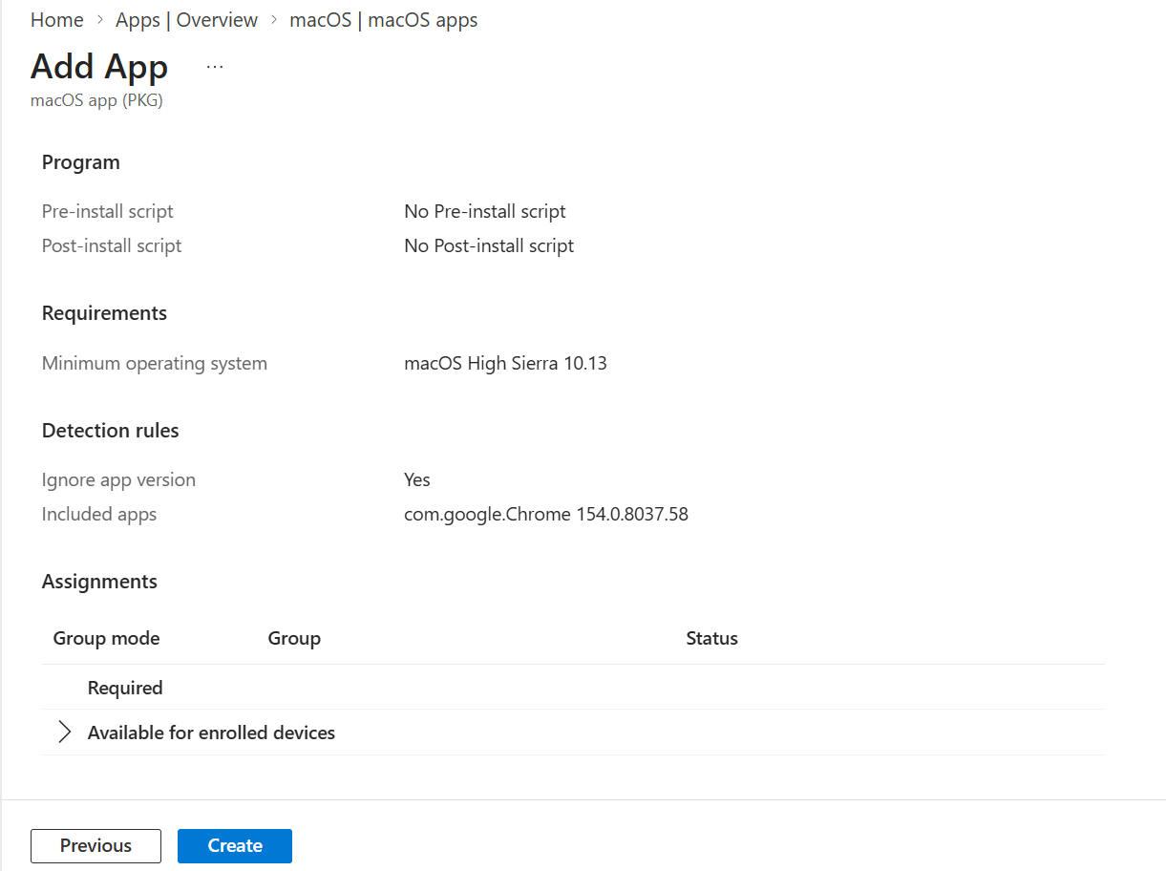
Step 19. Review Program, Requirements, Detection rules, and Assignments.
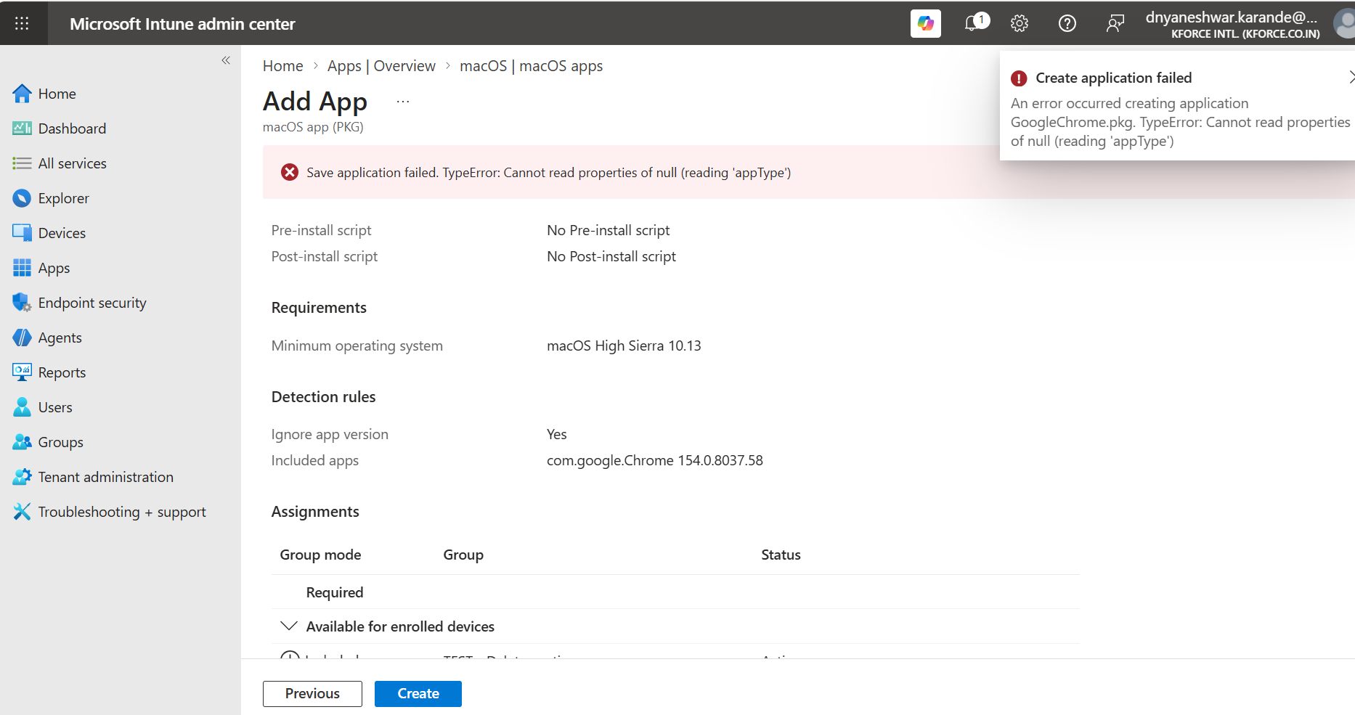
Step 20. Example creation failure indicates the PKG is unsupported or invalid.

11.1 If Create application fails
- Confirm the correct app type was selected for the package structure.
- Run sudo installer -pkg <file.pkg> -target / successfully on a test Mac.
- Check package signature and certificate chain with pkgutil --check-signature.
- Expand the package and inspect payload, nested bundles, scripts, and Distribution XML.
- Confirm the file is not corrupted and remains within current Intune size limits.
- If the package is a signed, managed component package, test Line-of-business app.
- If the package is complex, unsigned, script-heavy, or installs outside /Applications, macOS app (PKG) is normally the better route.
- Re-download from the official vendor source and retry.
pkgutil --check-signature GoogleChrome.pkg
pkgutil --expand-full GoogleChrome.pkg ./ExpandedChrome
sudo installer -pkg GoogleChrome.pkg -target / -verboseR

12. Other Built-in macOS App Types
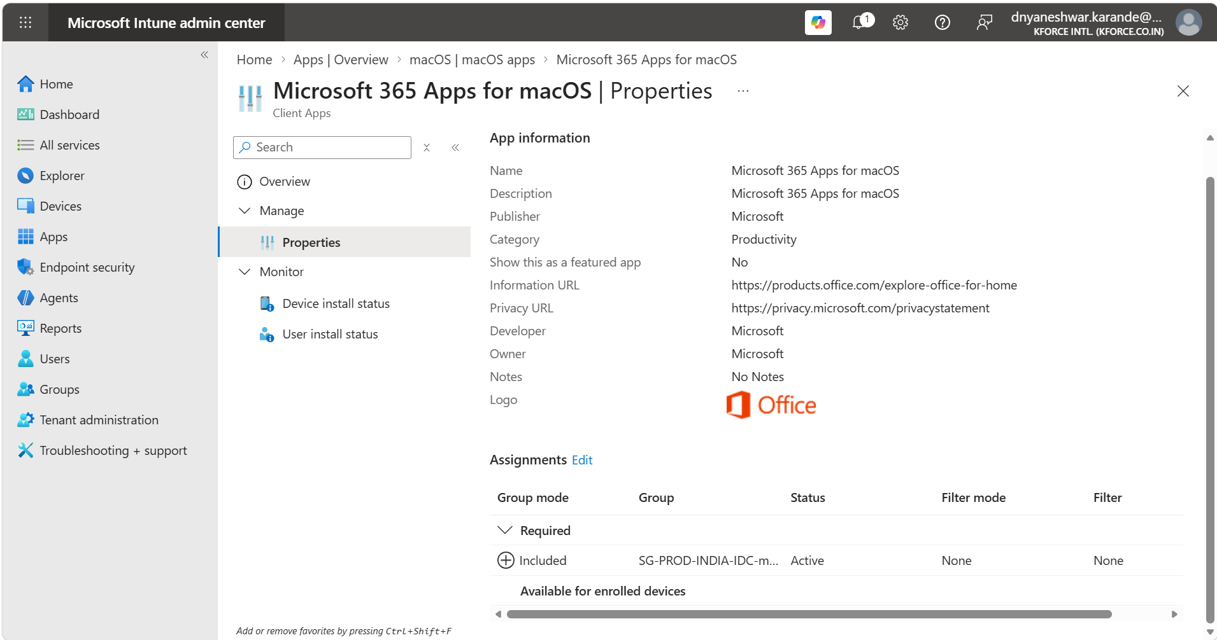
Microsoft 365 Apps for macOS properties and assignment example.
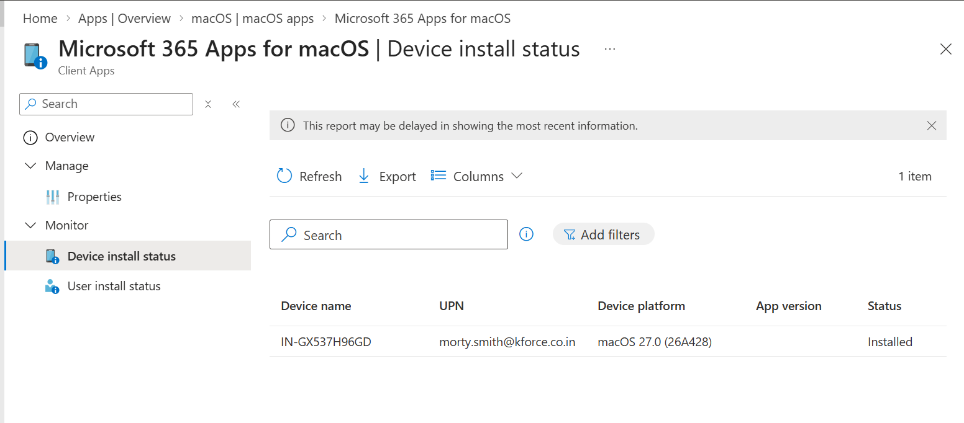
Device install status provides device name, UPN, platform, app version, and status.
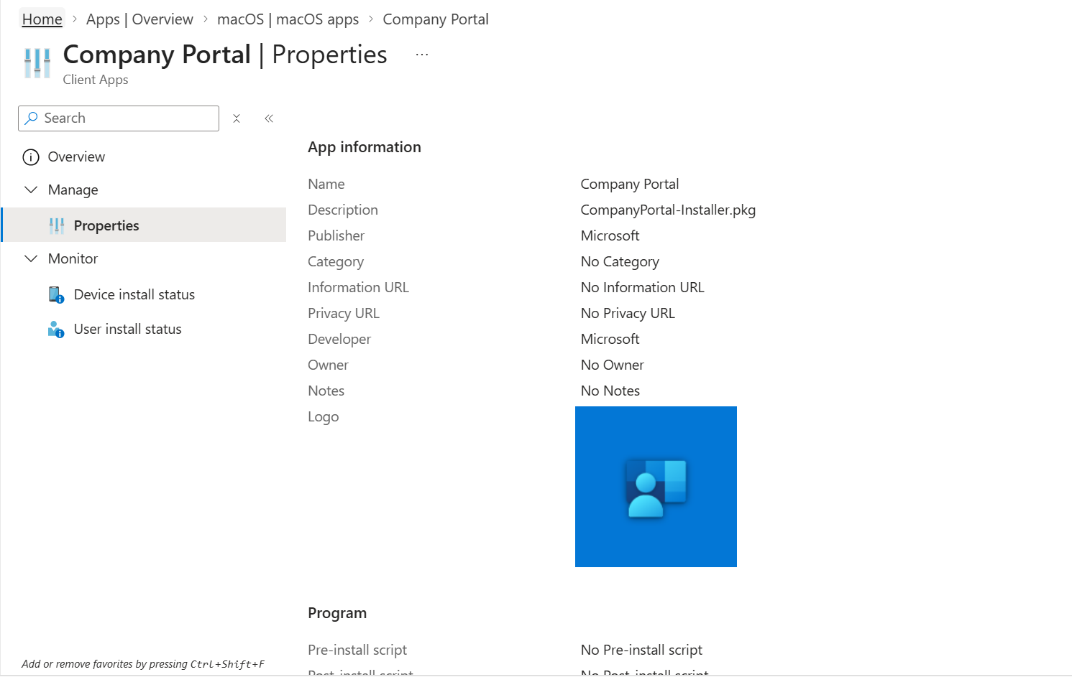
Company Portal properties, logo, metadata, and monitoring links.
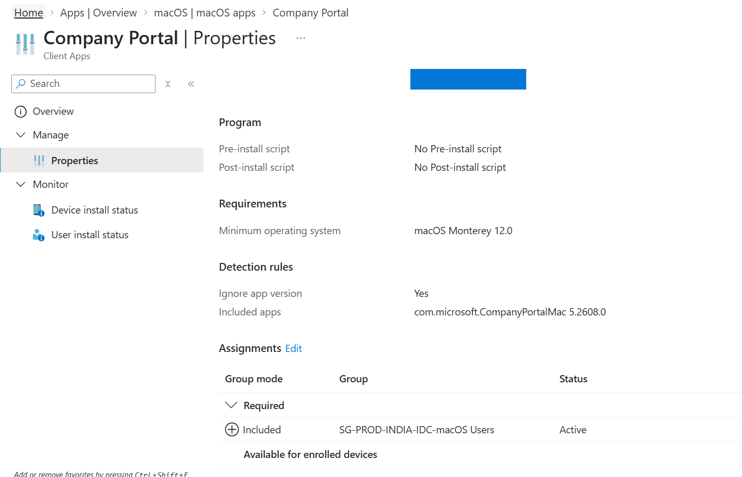
Company Portal requirements, included bundle, and Required assignment example.
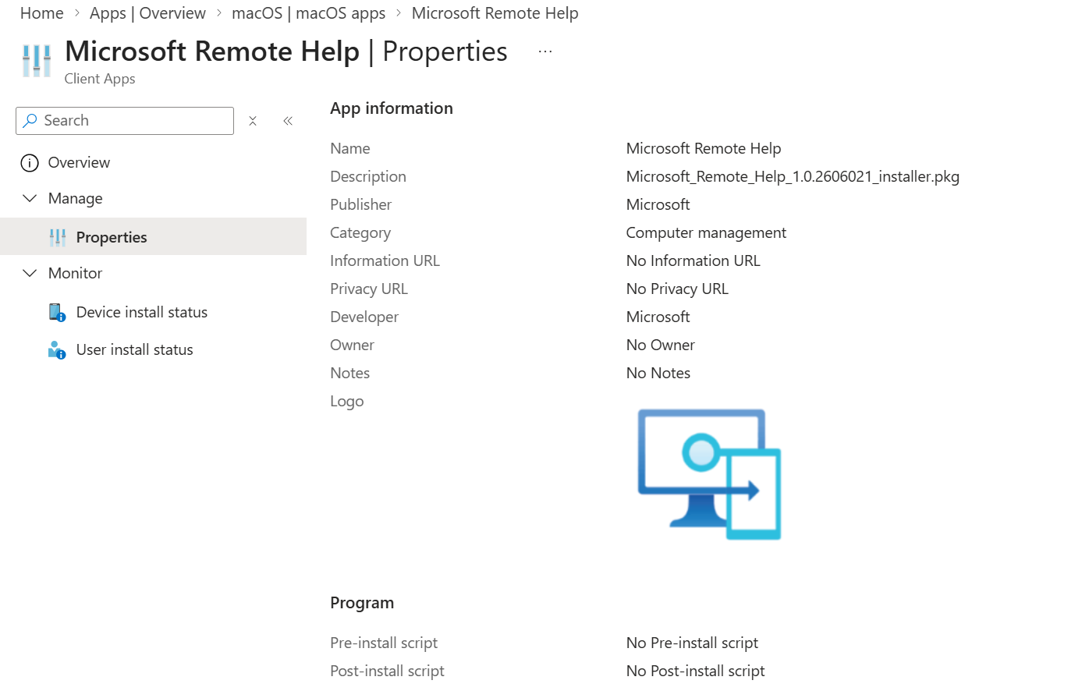
Microsoft Remote Help properties and application metadata.
Built-in app advantage
For supported Microsoft products, prefer dedicated app types because Microsoft provides product-specific deployment and update integration. App deployment can still require related profiles, permissions, onboarding, or licensing.

13. DMG and Managed LOB PKG Guidance

13.1 DMG
- DMG must contain one or more .app bundles; a DMG containing another installer type is not installed as a DMG app.
- Prefer one app, or only dependent app bundles, in a single DMG.
- Full Disk Access is needed to update or remove DMG apps; Intune requests this on supported macOS versions.
- For updates, upload a newer DMG using the same bundle identifier and validate the current Intune agent version.

13.2 Line-of-business PKG
- Use only .pkg.
- Package must meet managed LOB structure and payload requirements.
- Package must be signed with a Developer ID Installer certificate.
- LOB PKG has stricter requirements than macOS app (PKG).
- A logo is required for display in the apps section.
Capability | macOS app (PKG) | Line-of-business app | macOS app (DMG)
Typical use | Unmanaged/complex PKG | Managed signed PKG | App bundle in disk image
Package scripts | Supported | Package-dependent and stricter | Not installer scripts
Nonstandard paths | Supported scenarios | May not suit | No
Package signing | Can support broader package types | Developer ID Installer required | App/vendor dependent
Current documented size limit | Up to 8 GB | Up to 2 GB | Up to 8 GB

14. Monitoring and Client Validation

14.1 Portal
- Apps > macOS > select app > Overview.
- Review Device install status and User install status.
- Check assignment, group membership, device check-in, last status, version, and error code.
- Use the device record to confirm managed apps and synchronization.

14.2 Mac validation
# Verify app
test -d "/Applications/Google Chrome.app" && echo Installed
defaults read "/Applications/Google Chrome.app/Contents/Info.plist" CFBundleIdentifier
defaults read "/Applications/Google Chrome.app/Contents/Info.plist" CFBundleShortVersionString

# Intune agent logs and diagnostics
ls -la "/Library/Logs/Microsoft/Intune"
log show --last 1h --predicate 'process CONTAINS[c] "Intune"' --style compact

# Installer receipts
pkgutil --pkgs | grep -i chrome

14.3 Acceptance test
- Silent install succeeds.
- App exists in /Applications and launches.
- Correct bundle ID and version are detected.
- Required configuration profiles apply.
- No unexpected prompts or permissions failures.
- Intel and Apple silicon scenarios pass.
- Company Portal state and Intune report agree.
- Update and removal behavior are documented.

15. Troubleshooting Matrix
Symptom | Likely cause | Action
App creation fails | Unsupported PKG structure, corruption, wrong app type | Validate installer locally, signature, payload, and package type.
App not targeted | Assignment, group, filter, or enrollment issue | Confirm effective assignment and device check-in.
App remains waiting | Agent missing, device offline, dependency/security profile issue | Confirm Intune agent and sync; review logs.
Install fails | Vendor installer, script, permissions, disk, or architecture | Run installer locally with verbose output and inspect scripts.
Installed but reported failed | Bundle ID/version mismatch or wrong included app order | Read Info.plist and correct detection values.
Apple silicon failure | Intel-only package or missing Rosetta | Use Universal/arm64 package or deploy Rosetta when approved.
App launches but prompts for access | Missing PPPC, system extension, notification, or network profile | Deploy required configuration profiles before or with the app.
Available app not visible | Company Portal, licensing, duplicate name, assignment | Sync Company Portal and verify user assignment.
Update not applied | Same/older version, bundle mismatch, Ignore version strategy | Review update model, bundle ID, version, and assignment type.
Retired device retains app | App type does not remove payload on retirement | Use supported uninstall/removal method and document cleanup.

16. Advanced Lifecycle and Interview Preparation

16.1 Production lifecycle
- Maintain source, signature evidence, version, scripts, bundle IDs, assignments, testing, and rollback.
- Use configuration profiles to manage app settings.
- Pilot each new version on Intel and Apple silicon where applicable.
- Avoid overwriting a production app until update behavior and rollback are proven.
- Monitor vendor security releases and end-of-support dates.
- Retire assignments and validate removal behavior before deleting portal objects.

16.2 Interview questions
Question | Strong answer
PKG vs DMG? | PKG is an installer package that can place files and run scripts; DMG is a disk image that must contain deployable .app bundles for Intune DMG deployment.
What detects a macOS app? | Bundle identifier and version from the app bundle, with Included apps ordered for reporting and detection.
What is Ignore app version? | It controls whether version participates in detection; use it according to Intune-managed versus vendor self-update strategy.
Why can creation fail? | Wrong app type, unsupported PKG structure, invalid signature/payload, corruption, or package constraints.
What runs PKG/DMG deployments? | The Microsoft Intune management agent for macOS in supported scenarios.
Why use pre/post scripts? | For controlled preparation or finalization around a PKG, not to hide an unsuitable interactive installer.
How do you support Apple silicon? | Prefer Universal or arm64 packages, test architecture, and deploy Rosetta only when required.
Required vs Available? | Required installs automatically; Available is user-initiated through Company Portal.
How do you troubleshoot? | Check targeting, eligibility, agent, download, installer/script execution, bundle detection, then reporting.
What is PPPC? | Privacy Preferences Policy Control used to grant or manage privacy permissions for applications.

17. Reusable macOS Application Record
Field | Record
Application name
Vendor and business owner
App type
Installer file/version/size
Architecture
Vendor source URL
Signature result
Local install test
Bundle ID
Bundle version
Minimum macOS
Pre-install script
Post-install script
Required profiles / PPPC
Assignment groups
Update strategy
Removal / rollback
Monitoring evidence
Ticket / approver / package date

17.1 Final checklist
- Official enterprise installer used.
- Correct app type selected.
- Installer and signature validated on macOS.
- Bundle ID and version verified directly from Info.plist.
- Minimum OS and architecture approved.
- Scripts reviewed, silent, idempotent, and secret-free.
- Required configuration profiles prepared.
- Pilot group only for initial deployment.
- Install, launch, detection, update, and removal validated.
- Support and rollback documentation complete.

18. Official References and Maintenance
- Microsoft Learn: Add an unmanaged macOS PKG app to Microsoft Intune - https://learn.microsoft.com/intune/app-management/deployment/add-unmanaged-pkg-macos
- Microsoft Learn: Add a macOS DMG app to Microsoft Intune - https://learn.microsoft.com/intune/app-management/deployment/add-dmg-macos
- Microsoft Learn: Add macOS line-of-business apps - https://learn.microsoft.com/intune/app-management/deployment/add-lob-macos
- Microsoft Learn: Deployment guide to manage macOS devices - https://learn.microsoft.com/intune/fundamentals/platform-guide-macos
Maintenance rule
Review this SOP whenever Intune changes app types, package size limits, macOS agent requirements, detection behavior, update behavior, or Apple platform security requirements.

